How to inspire your children to garden - 15 outdoor games for the summer holidays
Saved
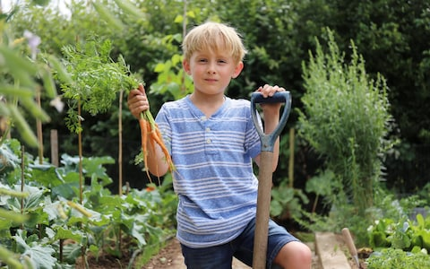Inspiring youngsters to plant and harvest is crucial to the future of the planet CREDIT: JOHN LAWRENCE
- Anna Tyzack
3 AUGUST 2019 • 10:00AM
Follow
On a hot day last week, my six-year-old son Hector sat at the garden table shelling his first crop of peas. It was a painstaking process and quite a few were lost on the ground, but I tried not to criticise – according to Sue Biggs, director general of the RHS, green-fingered youngsters are a rare species these days. “Parents, grandparents and teachers haven’t been pushing gardening as a pastime or a career,” she says. “And if we carry on like this, we won’t have enough gardeners to keep the 22 million gardens in this country going, and that will only make environmental issues worse.”
I’ve never grown vegetables, and if it wasn’t for the fact that my father has a vegetable patch, in which he lovingly planted out the pea shoots Hector grew from seed in recycled coffee cups earlier this spring, there would have been no pea crop. According to Biggs, the fact that parents are working longer hours is to blame for Britain’s dearth of young gardeners, along with properties having less outside space and a move away from rambling cottage gardens to manicured outdoor rooms.
Gardening also has “uncool” connotations, adds Lettie Irving from the RHS, as it’s associated with retirees and nursery schoolchildren – although hipster gardening TV presenters the Rich brothers and the RHS’s young ambassadors, George Hassall and Jamie Butterworth, are rebranding it as a cool way to connect with nature and support the environment. “Attitudes are definitely changing,” Biggs confirms. “If youngsters want to do anything to look after their planet, getting them gardening is the best way to start.”
The summer is not the best time to start planting and growing, Irving concedes, but there is still plenty for children of all ages to do out in the garden. “It’s more about conservation: looking after wildlife and keeping plants alive by closely observing how they’re dealing with the weather,” she says.
According to Cassie Liversidge, who runs gardening clubs at London schools, older children are fascinated by composting, harvesting and cooking fresh produce. “Gardening is more than growing a punnet of cress; it’s about understanding the earth,” she says. “The main focus should be getting kids comfortable around plants, mud and insects. Get them to rub basil or lavender between their fingers to release the scent; I’ve met five-year-olds who are terrified of plants.”
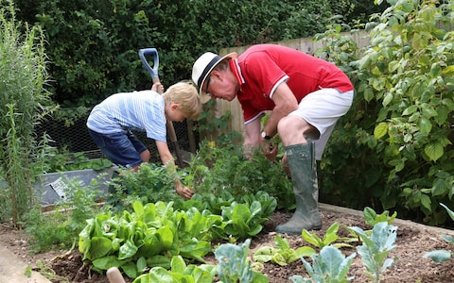
Hector Tyzack gardening with his grandfather David in Devon CREDIT: JOHN LAWRENCE
Horticulture is a blooming industry in Britain; worth £24 billion to the economy and supporting 570,000 jobs. Yet most children are unaware of the careers gardening can lead to, Irving maintains. The holidays are thus an opportunity to introduce them to floristry, garden design and garden art. “You can go on to be a plant scientist, a botanist or a tree surgeon,” she says. “And in the meantime you’re developing Stem skills – counting seeds, reading plant labels and learning to spot insects.”
There are so many resources available online that the least green-fingered parents can get their children gardening, Biggs says. You don’t even need to own a garden. Hector is telling anyone who will listen that he’s a gardener, and Liversidge insists this bodes well for the future. “When a child says ‘I’m a gardener’ it’s like saying ‘I can do maths’,” she says. “It doesn’t mean that everything they plant will grow, but it means they have the confidence to connect with plants.”

15 gardening games for the summer holidays

Play I-Spy
Download the RHS spotter’s guides, which help children get their eye in, recognising vegetables, weeds, insects and summer flowers. “If you can’t find the relevant plants in your own garden, go to a local park or garden,” Irving suggests. “Once you can recognise a red admiral butterfly or honey bee you also see which plants are most attractive to pollinators.”
For older children the RHS has Invisible Garden worksheets that ask more in-depth questions about plants and mini beasts. “They might also enjoy drawing a sound map with different symbols for birdsong, running water and insects,” Irving says.

Plant a miniature garden
Fill a wide, shallow planter with herbs, small perennials and succulents, and cover the surface of the soil with gravel. “Get creative and use lolly sticks as fencing and build structures for your plants to climb up,” explains Irving. “If you don’t have outdoor space, you can make an indoor allotment on a window sill by sowing microgreens in rows.”

Become a garden artist
Making plant labels, seed packets and labelling pots are fun garden activities but you can also create Andy Goldsworthy-style garden art on the grass, using sticks, stones and leaves. If you’re hosting a summer party, create garden bunting, Irving adds, by gluing leaves and twigs between triangles of tracing paper and threading them on to lengths of string.

Build a stag beetle lodge
A few pieces of leftover wood can easily be transformed into a habitat for stag beetles, says Irving. “Stag beetles lay their eggs in rotting wood, so all you need to do is sink wooden uprights into the earth then wait for them to move in,” she says.

Make a bird spa
Blackbirds and starlings enjoy taking splashy baths in summer and bathing, according to the RSPB, keeps their feathers in prime condition. Any shallow container – an upturned dustbin lid or large circular plant tray – can be upcycled into a makeshift bird bath. See rspb.org.uk.
Show more

Water power
If it involves water, younger children usually want to be involved. Make an upcycled watering can by punching small holes into the lid of an empty plastic milk container. Older children often enjoy designing ways to conserve water in the garden, by run-offs from gutters into buckets and water butts, adds Cassie Liversidge. Basic water butts with taps are available from local councils and DIY stores.

Brew up a tea garden…
A favourite with Liversidge’s two sons: fill a planter or window box with real tea plant Camellia sinensis (from crocus.co.uk) and herbal varieties – try chocolate and ginger mint, lemon verbena and sorrel, suggests Liversidge, whose book, Homegrown Tea, is a guide to planting, harvesting and blending teas and tisanes.

…Or create an edible garden
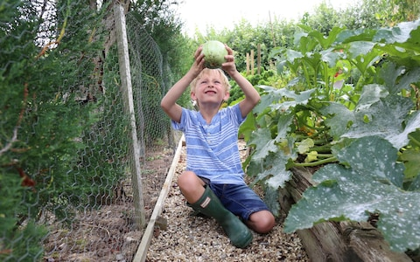
"Encourage them to plant one row one week and one row the next" CREDIT: JOHN LAWRENCE
Plant herbs such as basil, thyme and sage as well as quick-growing vegetables such as radishes, lettuces and carrots, Irving says. “Encourage them to plant one row one week and one row the next to learn about successional gardening – and put them in charge of watering and harvesting their crop.”

Gift it
Liversidge runs seed papermaking workshops (the next is on Aug 21-22 at Van Hage Garden Centre, Great Amwell) where children make plantable seed cards and gift tags. You can also make seed paper at home, she says: sprinkle wild flower seeds on to glue dots on recycled paper, then stick another piece of paper over the top. Or cheat and buy ready-made seed paper, envelopes and cards online from plantableseedpaper.co.uk.

Create a jam jar terrarium
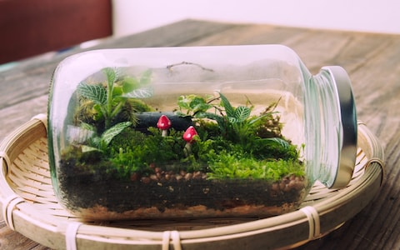
A jam jar terrarium CREDIT: GETTY IMAGES CONTRIBUTOR
You don’t need a garden for this one: fill a jam jar with compost mixed with sand (to aid aeration) and plant out tiny succulents and finish with fine gravel. “Succulents are all the rage this summer although you can plant anything that will cope with a hot, dry climate,” Irving says. “And you can buy tiny spray bottles online to water them with.” Mini succulent plug plants are available from best4garden.co.uk.

Make a wormery
Wormeries are a great way to demonstrate the natural cycle taking place in every garden, Liversidge says: they’re essentially a composting bin crawling with worms that turn kitchen waste into soil conditioner and liquid fertiliser – horrifying and fascinating to children in equal measures. You can buy luxury wormeries online at originalorganics.co.uk (£79.99 including worms, bedding, and treats) or you can make your own using a plastic container with a lid and a few holes drilled into it; worms can be bought online at yorkshire-worms.co.uk.

Grow carnivorous plants
Carnivorous plants inspired RHS young ambassador George Hassall, 13, to start gardening. He recommends starting with the purple pitcher plant before attempting the Cape sundew, which has tentacles to catch prey, and the Venus flytrap – you can buy them online at hantsflytrap.com. “Water them with rain water and keep them in a sunny position,” he says, warning that carnivorous plants will need plenty of TLC.

Prepare the crop – and cook it
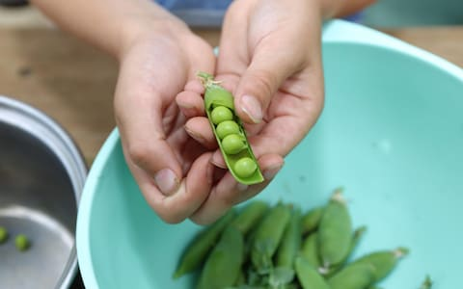
Hector Tyzack shelling peas picked in his garden CREDIT: JOHN LAWRENCE
“Give them a bowl of broad beans to shell – they love the way the pod is squashy like a sleeping bag,” Liversidge says. “Shelling peas and picking kale require dexterity and fine motor skills that many children don’t have any more.” She’s written a series of “Grow Your Own Ingredients” books to inspire children to make pasta sauces and jellies from their own produce.

Design a bouquet
Montessori schools use flower arranging to encourage independent thought, creativity and logic. Floristry is also a great way to get older children inspired to grow cut flowers, adds Biggs. Start with home-grown flowers or loose flowers from a local florist; then sign up to a course: schooloffloristry.com runs children’s courses throughout the year; while thekitchentableflorist.co.uk hosts floristry birthday parties.

Go on garden adventures
Take your children to as many gardens as possible, urges Liversidge. “And point out flowers and shrubs; when they see all the different species on the coast and the mountains they will understand what climate means.” The RHS gardens are essentially garden labs, Irving says, with experimental planting and experts on hand for advice – although your local garden centre is a great place to start.

